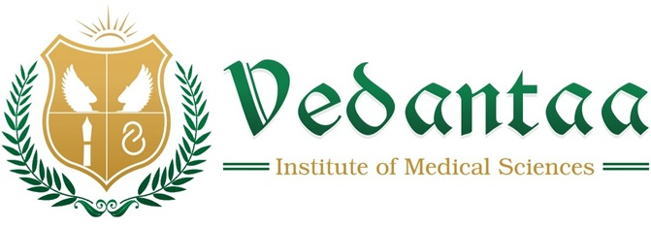

SMARTT Initiative for Suicide Prevention – Reel Making Competition
The SMARTT Initiative for Suicide Prevention conducted a State-Level Reel Making Competition for UG Medical Students of Maharashtra based on the theme: “You Are Not Alone – Hope, Help and Healing.”

The competition encouraged participants to creatively express messages of mental health awareness, hope, and support

Our students Ms. Abhilasha Sahebrao Narwade (Batch 2021) ,Deeba Ansari (2023 Batch), Prachiti Thakur( 2024 Batch), Vedantaa Institute of Medical Sciences, Dahanu, Palghar, secured the 1st prize (1st Prize – ₹10,000) at the state level, bringing great pride to Vedantaa Institute. Congratulations for this remarkable achievement and for bringing glory to our institute.

